Call for Proposals – Expert Facilitator to deliver CIRCULÉIRE’s Thematic Working Group on ‘End of Waste, By-products and Waste Licensing Pathfinders’
CIRCULÉIRE - the National Platform for Circular Manufacturing - is requesting applications from suitably qualified ‘Expert Facilitators’ to lead its forthcoming Thematic Working Group on ‘End of Waste, By-products and Waste Licensing Pathfinders’.
Thematic Working Group (TWG) Process and Aims
Each year for the duration of the programme, CIRCULÉIRE’s industry members vote on topics that they deem strategically important to enabling – or preventing - their transition to a circular economy. In 2022, End of Waste, By-products and Waste Licensing was selected as the top priority topic for the network to run a Thematic Working Group on.

“End of waste” and by-product notifications are recognised as playing a key role in a circular economy. They do this by helping to establish a market for a wide range of secondary raw materials, improving resource management, encouraging symbiotic industrial practices, and preventing resources from being sent for disposal. By maintaining resource value within the economy, successful application of End of waste and by-product status reduces the environmental impacts arising from waste disposal. Nevertheless, “End of waste” and by-product regulation is often poorly understood by certain sectors of Irish industry, which amongst other challenges, can result in poor engagement or unsuccessful applications.

The aims of this TWG are thus as follows:
- Increase CIRCULÉIRE’s Industry Members knowledge and understanding of the EoW and By-products regulatory regime (particularly within the context of responsible innovation and circular economy);
- Clarify the roles and responsibilities of key stakeholders within the wider regulatory regime, such as local authorities, the EPA, DAFM etc.;
- Co-produce high-quality thought leadership with input from the panel members and CIRCULÉIRE’s Industry Members aimed at advancing Irish industry’s circular transition (proposing practical, actionable recommendations as appropriate);
- To design and deliver 2x Ideation Workshops where the working group identify min. 5-10 innovations (both at industry-specific product and policy levels) that support a circular economy. Product innovations should be based on the nationally important waste or by-products clusters identified in advance by the Expert Facilitator and should demonstrate potential to reduce GHG and waste if diverted from disposal.
Key Activities to be delivered by the Expert Facilitator
Over a 12 – 16-week period the successfully appointed Expert Facilitator will deliver a series of meetings, seminar, ideation workshops and webinars; each aimed at achieving the objectives of the TWG.
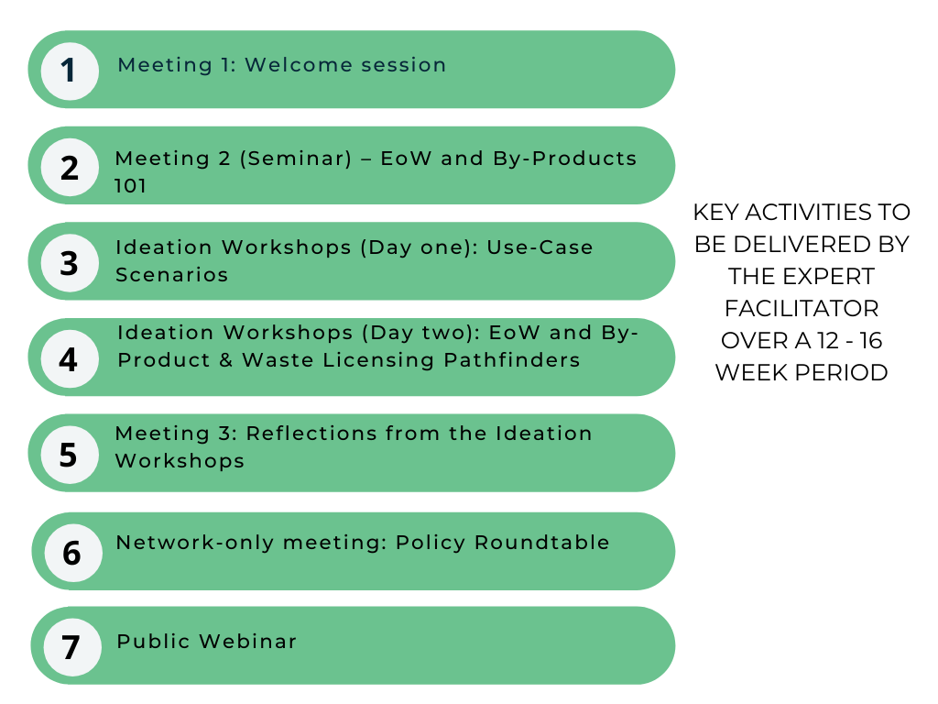
Table 1. Scope of Work and Deliverables
Activity | Anticipated Scope | Output
8-10 one-to-one calls with CIRCULÉIRE Industry Members | - To ensure the activities and final deliverables meet industry needs, it is anticipated that the Expert Facilitator will lead 8-10 one-to-one short (circa 30-minute) calls with CIRCULÉIRE members at key points in the TWG process to identify key challenges and innovation opportunities to be focused on. | - Minutes to be shared with CIRCULEIRE
Meeting 1: Welcome session | - Icebreaker and welcome  - Clarifying the distinctions between waste and by-products and their relationship to a circular economy  - Overview of the role different stakeholders play (local authorities, EPA, DAFM, Transfrontiers Shipments, etc.)  - Assessing what industry and non-industry panel members want to get out of the TWG | - Slides to be circulated following the meeting
Meeting 2 (Seminar) – EoW and By-Products 101 | - Explanation of key terminology, concepts and considerations for industry when preparing EoW and By-product position;  - Overview of examples of nationally important waste and value streams;  - Steps and tips when preparing a strong EoW or By-product application;  - Potential to involve industry guest speaker to hear about their experiences and lessons learnt successfully applying for EoW / by-Product status;  - Worksheet to be developed aimed at guiding Industry members to progress EoW / By-product applications with their own waste and materials inputs;  - Q & A; | - A recording of the seminar to be made available for CIRCULÉIRE’s industry members
Ideation Workshops (Day one): Use Case Scenarios – Strategically Important National Waste Streams  (In-person / Online Workshops) | - Expert facilitator to prepare 5-7 examples of nationally important waste and material stream clusters (e.g. industry-specific) which can be used to structure the Ideation Workshops group exercises;  - Group exercise to be designed around interrogating use-case scenarios for the waste streams clusters, mapping out the steps needed to do a) EoW / By-product test; b) Prepare an EoW/By-product application; and c) Interrogate the environmental impacts and other key considerations;  - Aim should be for the working group to identify min. 5 hypothetical innovative and impactful products or applications (based on the waste or by-products clusters identified) which could reduce GHG and waste if diverted from landfill disposal, and which take into account the wider environmental and human health considerations; | - Short Ideation Workshop report
Ideation Workshops (Day two): – EoW and By-Product Pathfinders  (In-person / Online Workshops) | Interactive group exercises to assess:  - Aspects of the EoW / By-product regimes industry are now familiar with/engage with effectively;  - Outstanding knowledge gaps / barriers in preparing EoW / by-product position;  Final half-day Co-design session – EoW and By-Product Pathfinders:  - Interactive team exercises to generate ideas for new ‘EoW, By-product and Waste Licensing Pathfinders’ i.e. innovative approaches or ways of working, such as at a sectoral level, or innovative tools - such as new platforms, artefacts or resources, which could improve Irish industry’s circular economy outcomes in the EoW / By-products regime; | - Ideas for 1-2 practical industry-focused artefacts (such as a fact sheet / infographic)
Meeting 3: Reflections from the Ideation Workshops | - Summarising and refining the key takeaways and innovation opportunities identified during the Ideation Workshop;  - Expert Facilitator to present 2-3 examples of how EU member countries have optimised EoW, By-product and waste licensing regime for a CE;  - Gather insights about recommendations regarding how the EoW / By-product regime might be enhanced for circular economy in Ireland; | - Short 3–5-page policy briefing
Network-only meeting: Policy Roundtable | - Presenting headline results from the Ideation Workshop Report and Policy Briefing for discussion;  - TWG key recommendations for discussion with the EPA; DECC; DAFM (and other key decisionmakers); | - Policy briefing
Public Webinar | - Summary of key results from the Ideation Workshops;  - Finalised recommendations from the TWG;  - Promoting the final outputs; | - Webinar recording
Expected Final outputs:
- 1-2 short practical co-designed artefacts (such as a fact sheet / infographic) to be developed based on industry need e.g. how to effectively navigate the EoW / By-product regime, who to engage, etc.
- Blog (to be published on CIRCULÉIRE’s website) – e.g. short Q&A on lessons learnt from Irish industry player / EoW practitioner reflecting on how to improve likelihood of successful applications
- 20 – 30-page Ideation Workshop report that summarises the main activities delivered in the Ideation Workshops, and details of 5-10 innovation opportunities identified by the working group (based on the nationally important waste streams and resources with potential for EoW or By-product designation initially identified by the Expert Facilitator)
- A 3-5 policy briefing that summarises key challenges and/or opportunities identified by industry and recommendations about key decisionmakers might address them
About the Expert Facilitator
The successful consultant will have a deep understanding of the Irish waste management and circular economy policy and regulatory landscapes, and a proven track record providing technical expertise to industry with successful End-of-Waste and By-product applications and waste licensing compliance. They will be comfortable undertaking background research to identify nationally important waste or by-products clusters, ensuring the Thematic Working Group process is streamlined to support the panel members’ learning needs.
The Expert Facilitator will support the goals of the Working Group by delivering well-designed workshops, meetings to the Working Group’s circa 20 panel members - consisting of a mix of CIRCULÉIRE industry members and actors from the wider Irish innovation ecosystem - to identify circular innovations at the product and policy levels related to End-of-Waste and By-Products. It is therefore advantageous that the Expert Facilitator have demonstrated experience facilitating group exercises, and successfully leading co-design and ideation workshops or events in the past.
They will be responsible for producing high-quality industry-focused deliverables and outputs in a timely and efficient manner, that address industry need in this domain.
Ensuring good cross-organisation alignment
The successful Expert Facilitator will play an important role in achieving the strategic objectives and impacts of the network. To ensure good cross-organisational alignment between CIRCULÉIRE Secretariat (IMR), and Strategic Partners (e.g. the EPA and DECC), the Expert Facilitator is expected to attend some internal meetings at key points in the process. Some ad hoc check-in meetings with IMR will also be required ahead of key activities.
2022 TWGs Indicative Dates
Kicking off in late May 2022, this Thematic Working Groups (TWGs) will run until September (Q3-4), 2022 for a period of approximately 12- 16 weeks. Questions on this specification should come in writing to IMR (details below). We will collect questions until Wednesday, 20th of April.

All compliant tenders (please complete and submit accompanying Excel Application to aide evaluation) will be assessed against relevant knowledge and experience, and proposed approach to delivering the activities. This work has a maximum allowable budget of €20,000.00 ex. VAT.

Indicative dates on the Call for Proposal:
- Q&As from IMR to submitting parties by Wednesday, 20th of April
- Deadline for RFP submission to circuleire@imr.ie: with subject heading ‘Expert Facilitator application - ‘End of Waste, By-products and Waste Licensing Pathfinders’: Wednesday, 27th of April
- Interviews with shortlisted applicants: W/C 2nd May
- Communication of winning proposal(s): W/C 9th May
- Kick-Off Meeting with to Agree Timeline: W/C 16th May
- TWG commences: W/C 30th May
IMR Contact Person: Sophie Reynolds, Circular Economy Technologist; E: sophie.reynolds@imr.ie
About CIRCULÉIRE
CIRCULÉIRE’s mission is to demystify, derisk, and deliver circular business model innovation by unlocking the value that resides in an Irish circular economy. CIRCULÉIRE is a public-private partnership created by Irish Manufacturing Research and the Department of the Environment, Climate and Communications (DECC), the Environmental Protection Agency (EPA), and EIT Climate-KIC with 25 Founding Industry Members.
Between 2020 and 2022, CIRCULÉIRE will take manufacturers and their supply-chains on a journey from linear to circular business models through baselining, auditing, business case development and deep demonstration innovation projects delivering significant reductions in greenhouse gas emissions (GHGs) and in waste production across the network.

The Expert Facilitator is encouraged to do sufficient preparatory work to in preparation for the Ideation Workshops to ensure that the Working Group is guided to identify high-quality, and environmentally impactful innovation opportunities (both at industry and policy levels). Some supplementary research may be required by the Expert Facilitator when drafting the Ideation Workshop Report to work up these ideas following the Ideation Workshops.
Near-final drafts should be produced for all final outputs review and comment by CIRCULÉIRE’s secretariat, IMR / another appointed external peer reviewer. The finalised version of all outputs should have key comments addressed.
A more detailed timeline will be agreed with the consultant as service contracts are being drawn up. Activities are envisaged to pause for the month of August.

